Common components

for

CTI (Chubb Travel Insurance) sites

**Quote Component and Quote Page (Out of scope)**

Please note that we are in the process to exclude the quote form from the CMS. This means we will **exclude all quote forms** to be built within the CMS. Please do not include this as part of the scope.

Below are some of the examples of the quote form, it could appear on the home page or a site navigation, or a page.

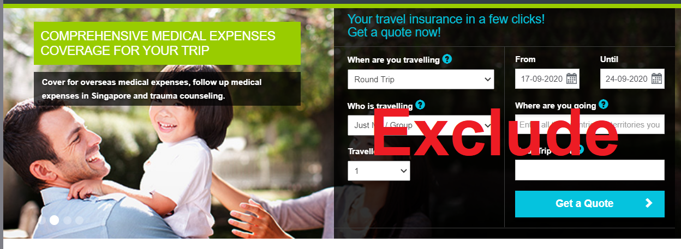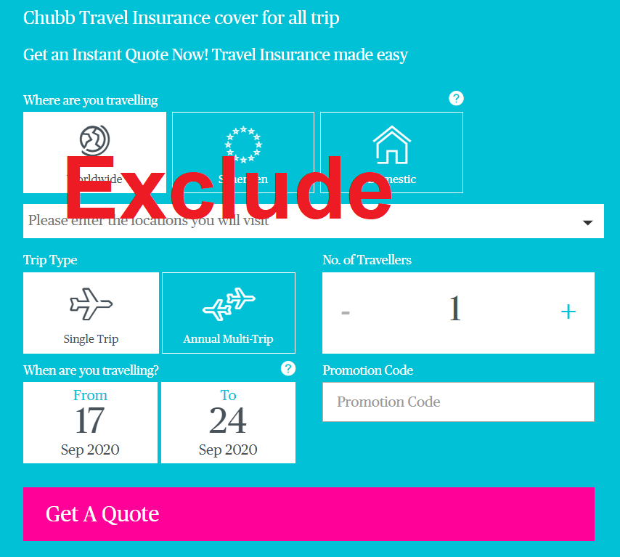 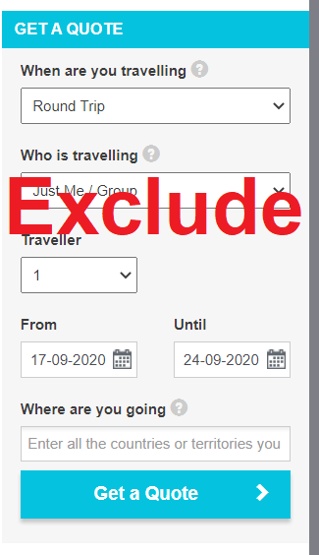

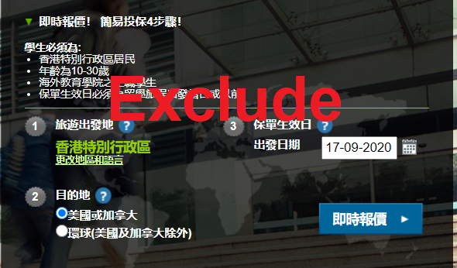

For the example of CTISG (refer to <https://www.chubbtravelinsurance.com.sg/en/>), the quote form will be replaced with just a button and the quote button will link to an external site.

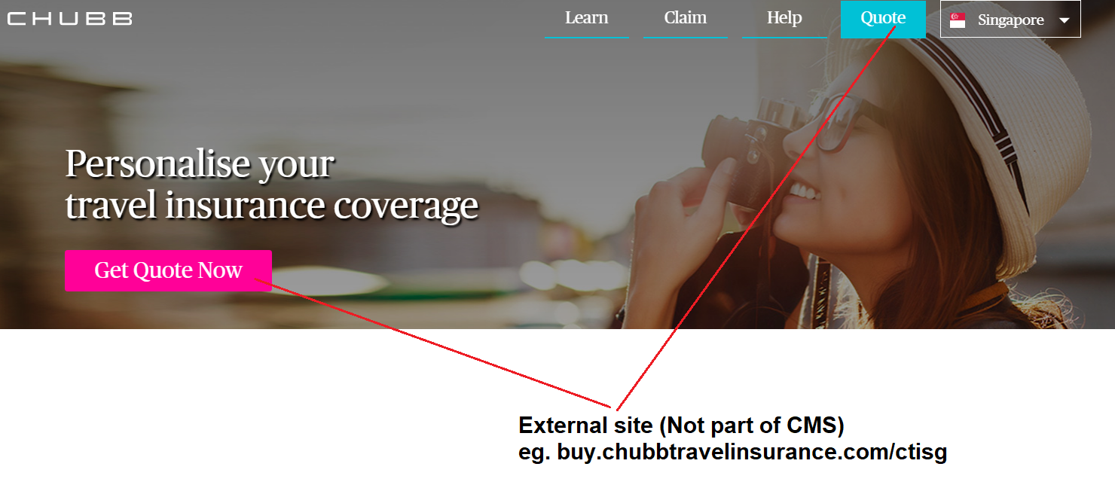

**Header Component (CTI Design)**

Below are some of the headers design for the CTI sites.





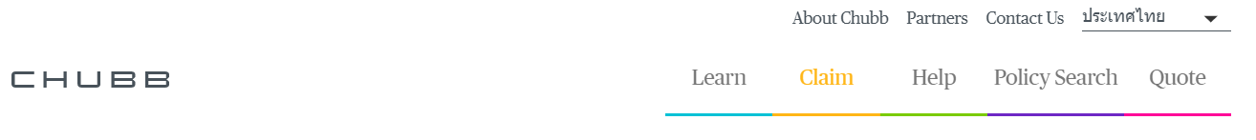

Some of the navigations can be expanded, some are links to other pages. The sub-headers are clickable links, which will redirect use to the specific page.

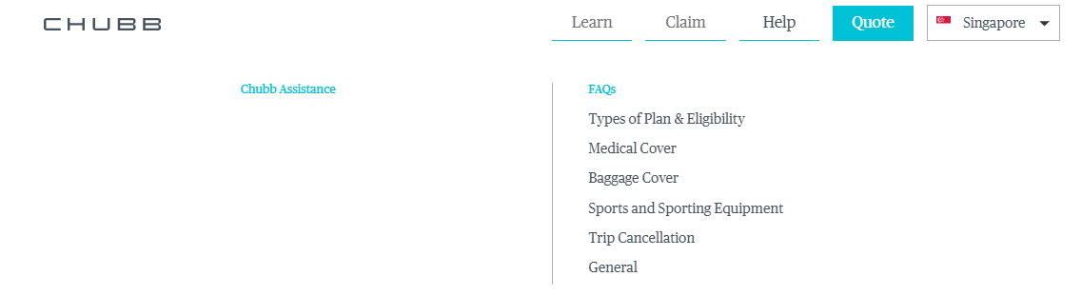

The links under the sub-header can also redirect user to a specific section of a page via anchor hash. The following is an example for FAQ link to a specific section in the FAQ page

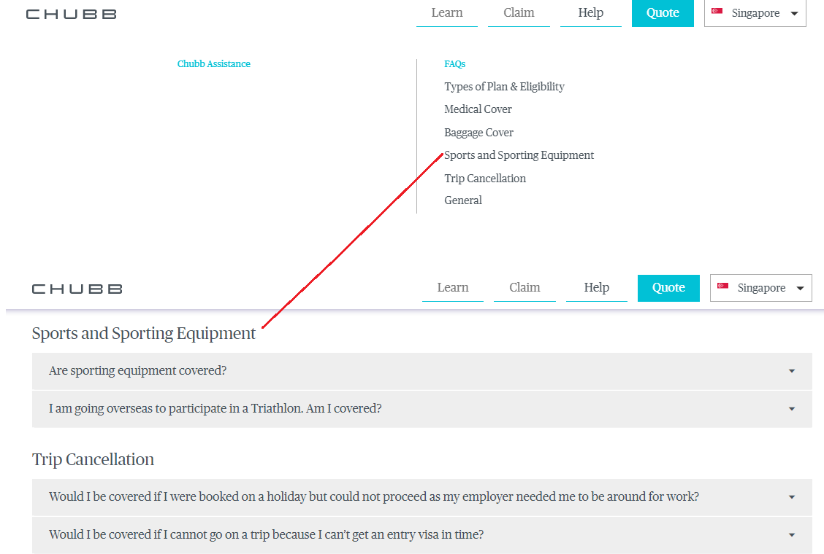

**Global countries/locale selector component**

This component allows user to change the language of the site, or switch to other CTI sites globally. This component will be according to the styling configured for the current active site.

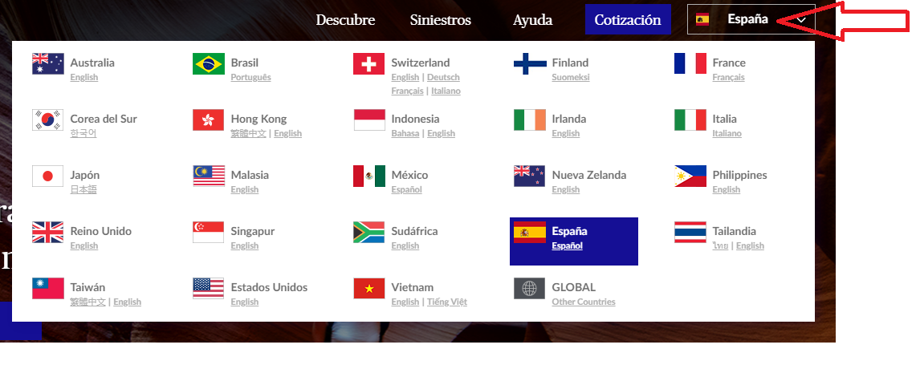

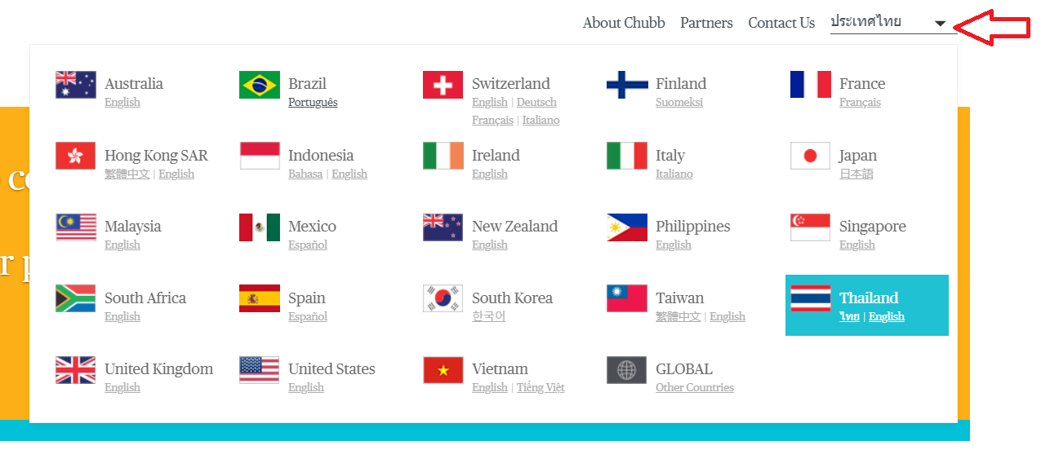

**FAQ Component**

(eg: <https://www.chubbtravelinsurance.com.sg/en/help/faqs>)

There’s a filter which will display the relevant category of the FAQs

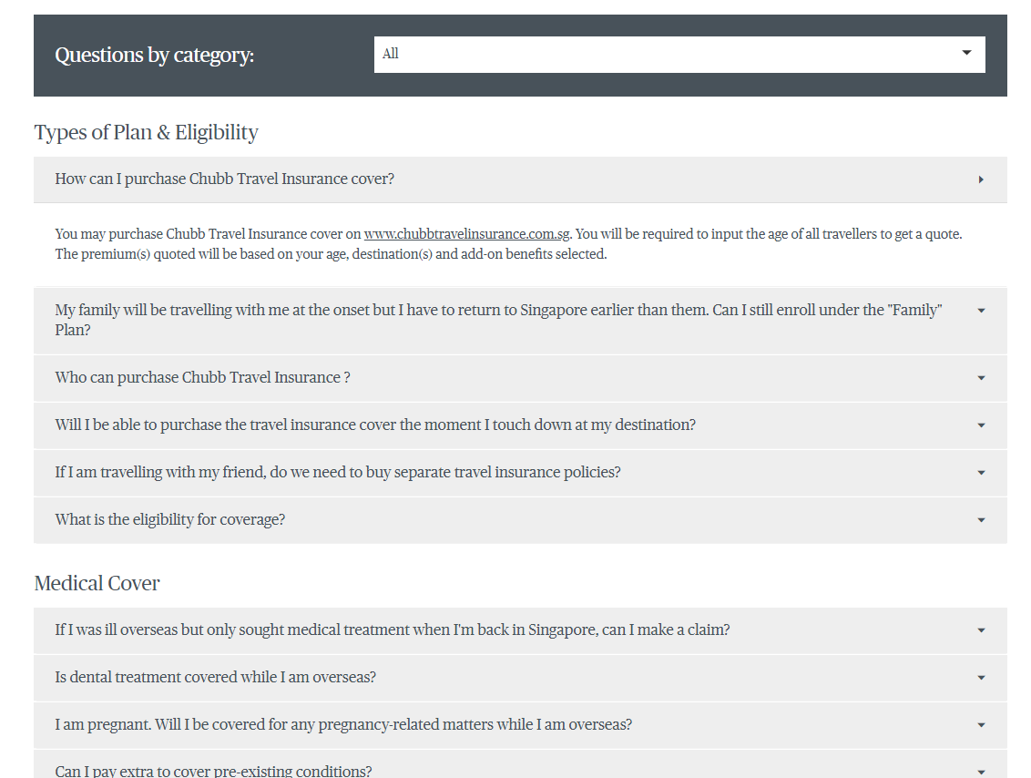

**What is covered Component**

(eg: <https://www.chubbtravelinsurance.com.sg/en/learn/our-products/what-is-covered>)

This component allows the user to filter the plan benefits by plan. Please note that the checkbox for the plan is dynamic depending on the products(site). For the example below, this site has 4 different plans.

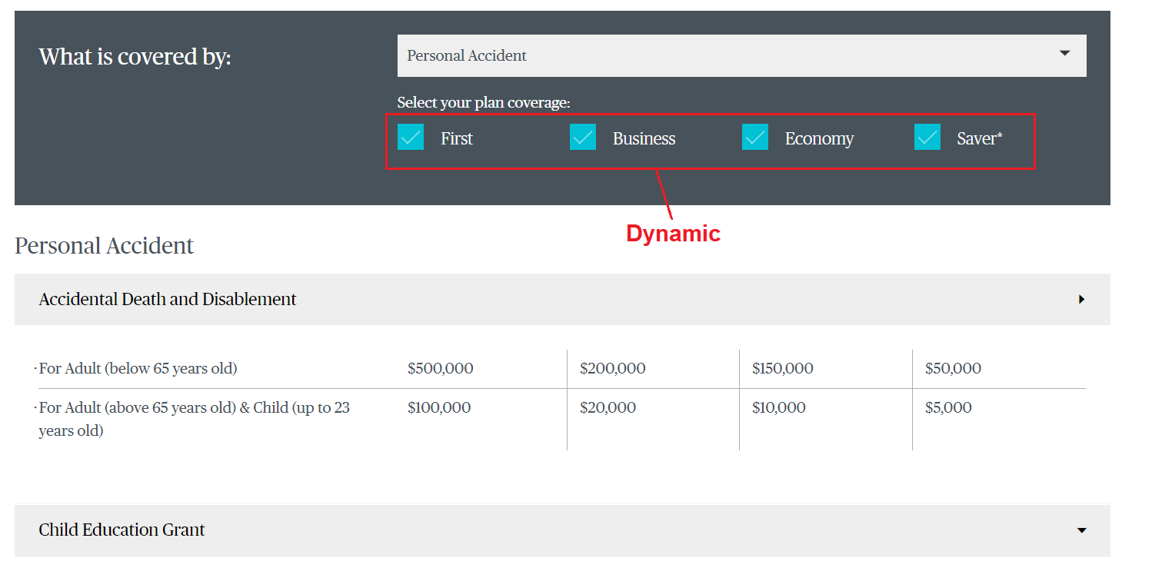

The example below shows when there is only 3 plans, there will be 3 check-boxes.

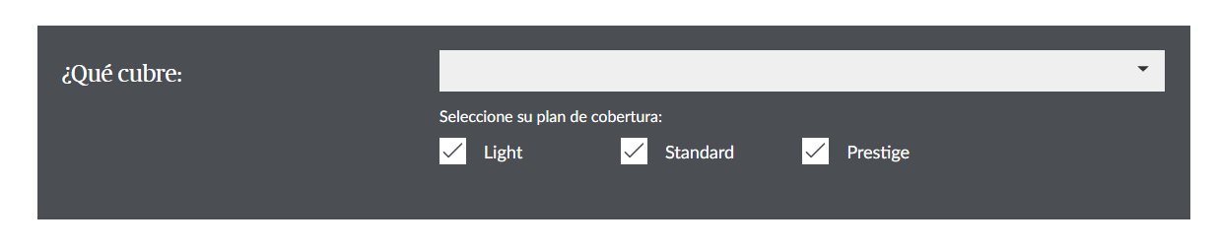

**Boxes Component**

1 Box

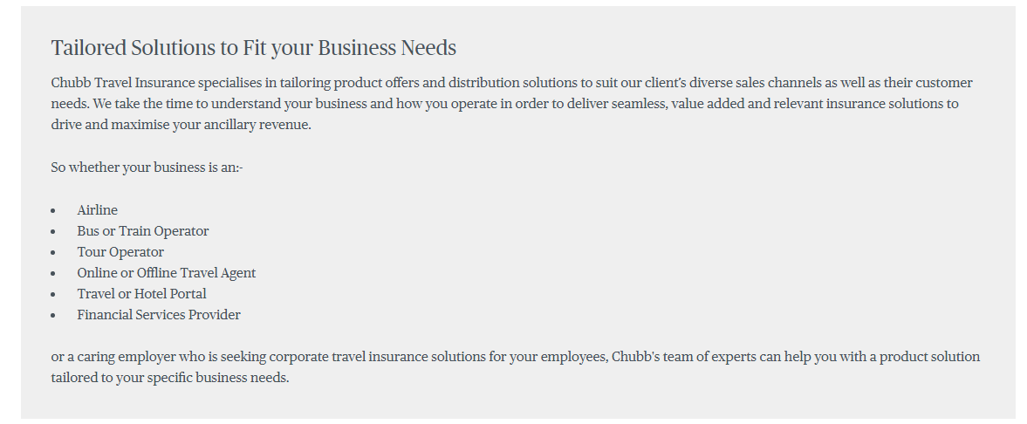

2 Boxes

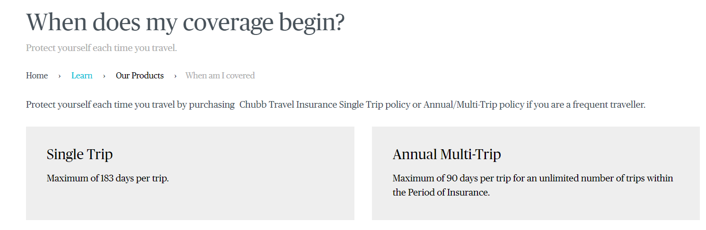

4 Boxes Component

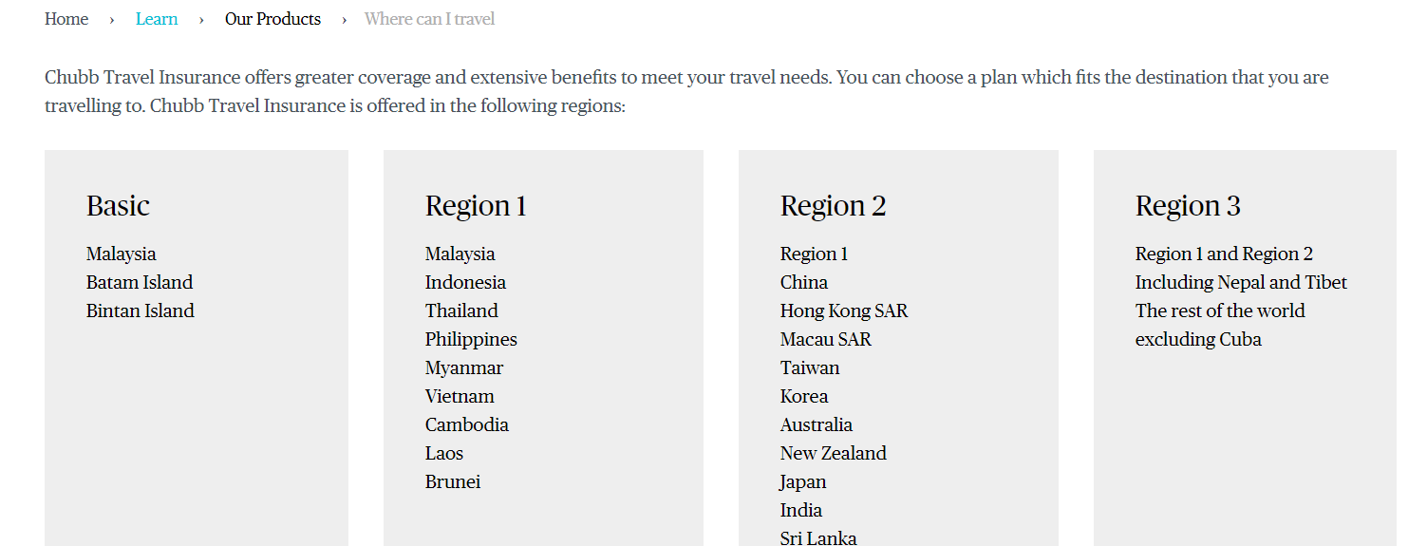

**Travel Tips component**

(eg: <https://www.chubbtravelinsurance.com.sg/en/learn/travel-tips>)

This component is a quick introduction of the travel tips, with a more button which will display more boxes. Upon clicking Read More in the box, user will be redirected to the individual travel tips page.

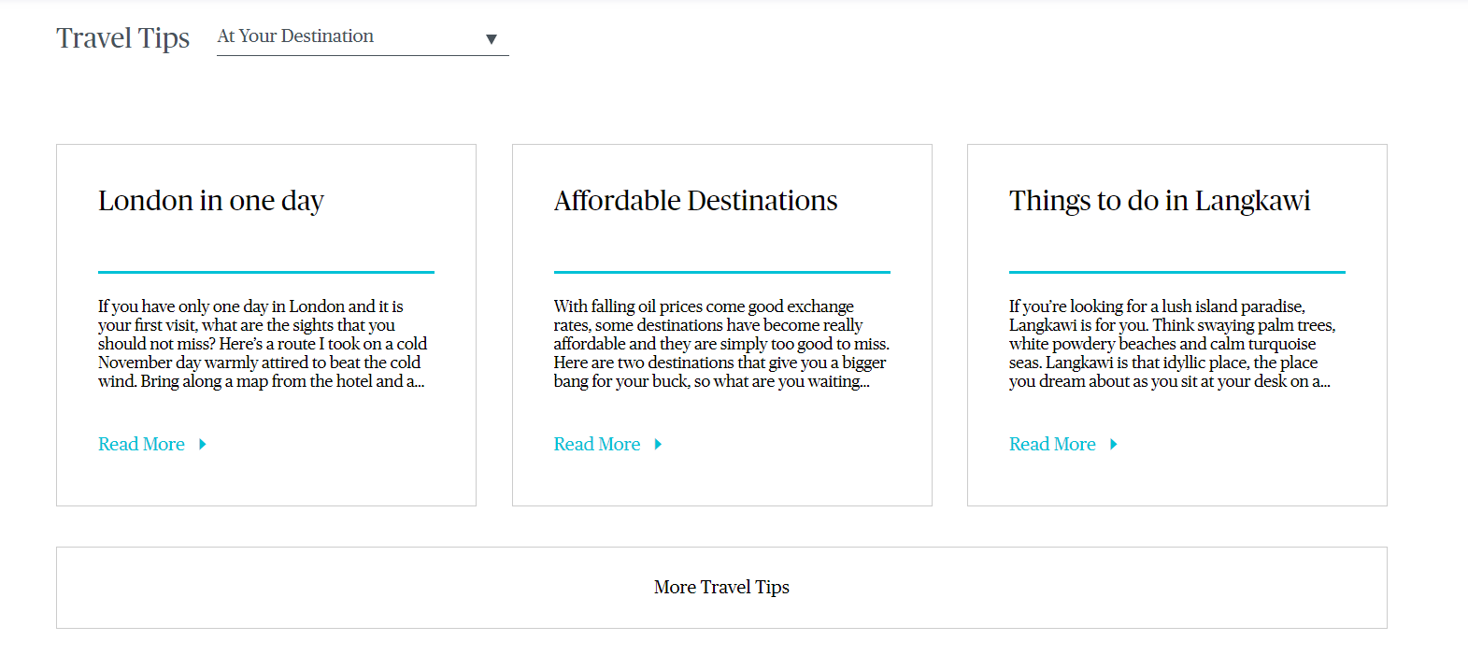

This component can also be placed under the individual travel tips page (<https://www.chubbtravelinsurance.com.sg/en/learn/travel-tips/at-your-destination/london-in-one-day>)

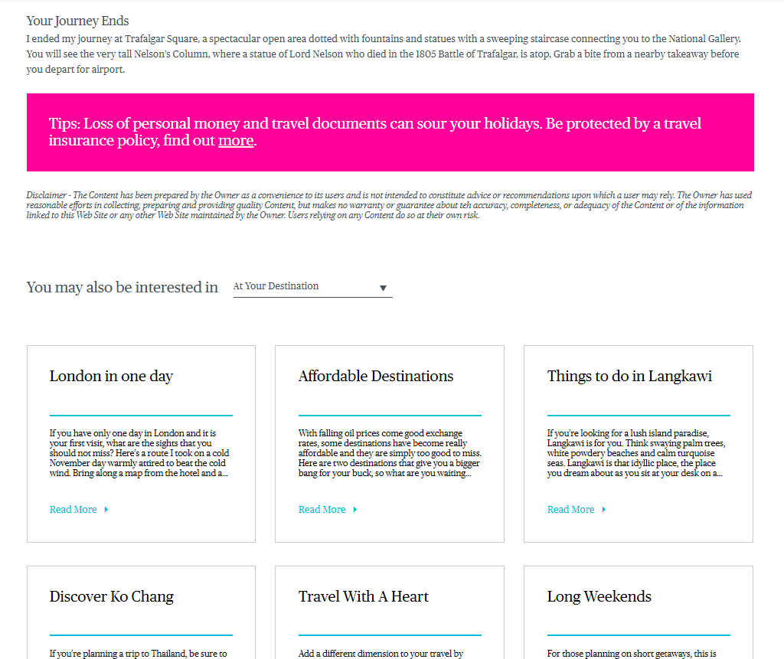

**Banners with button**

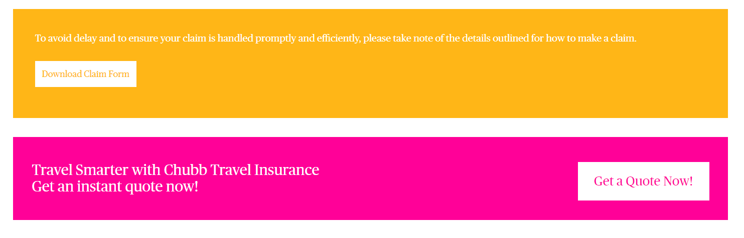

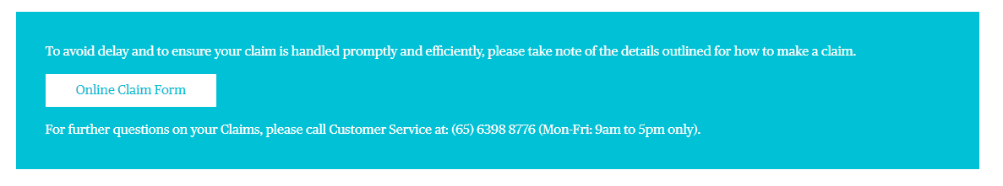

Some banner (blue) can be part of the content

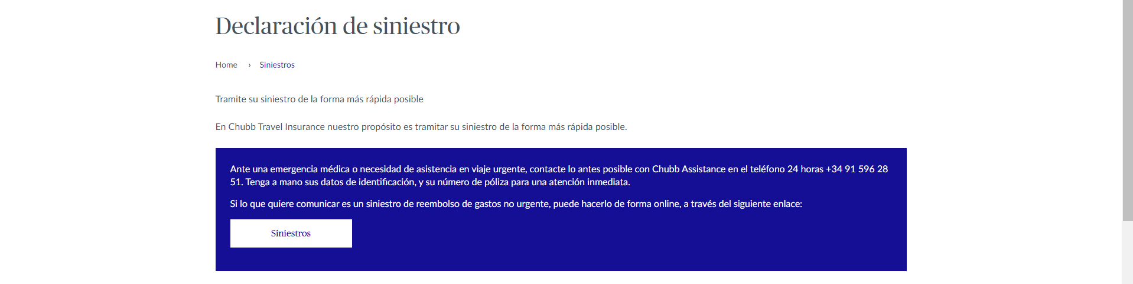

Some banner (yellow below) can span across the entire width of the page

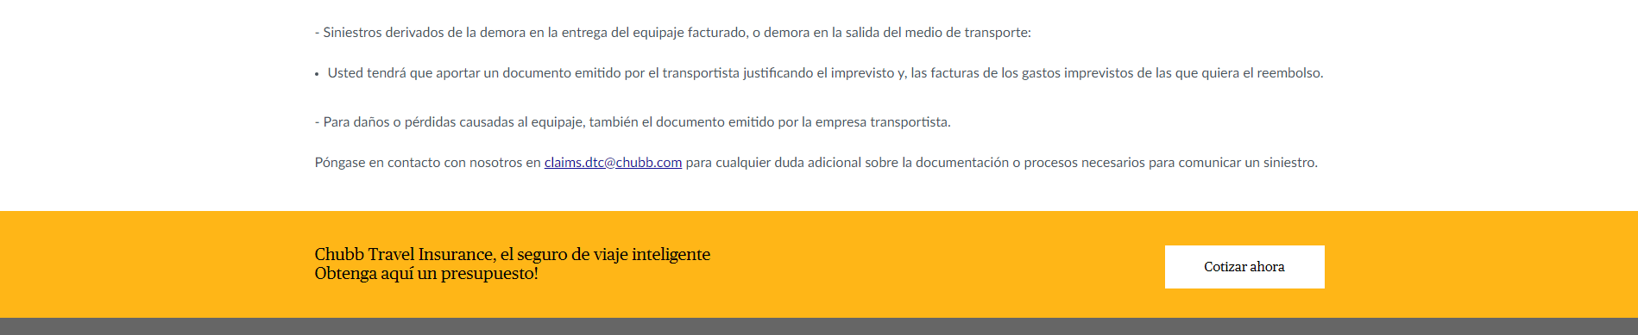

**Contact Us Form Component**

This form will collect data customer data and post it to the configured email address (eg. Call center, customer representative).

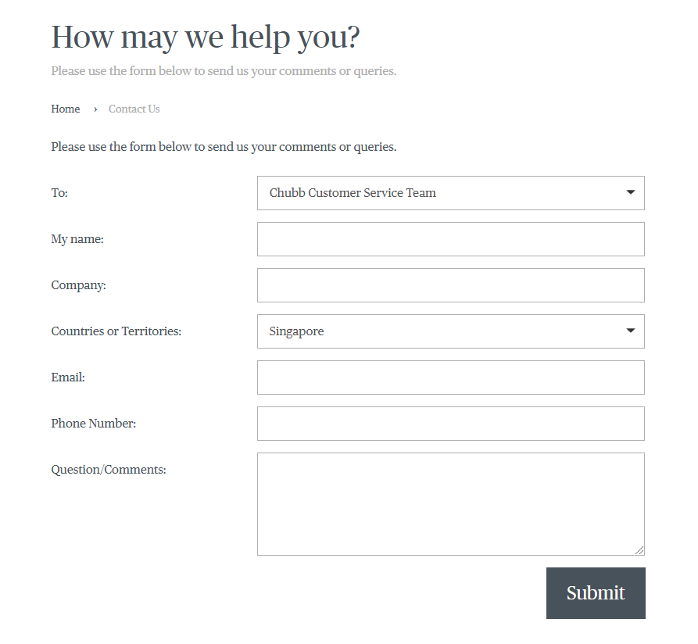

**Footer Component**

**CTISG (New design)**

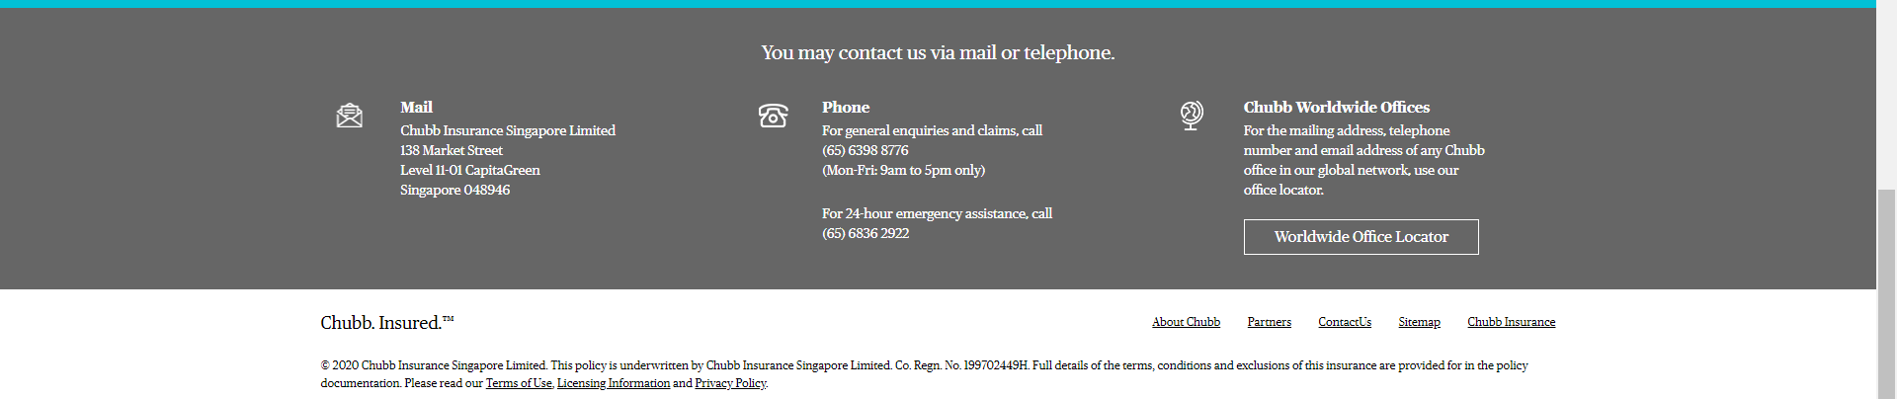

**CTIES (New design)**

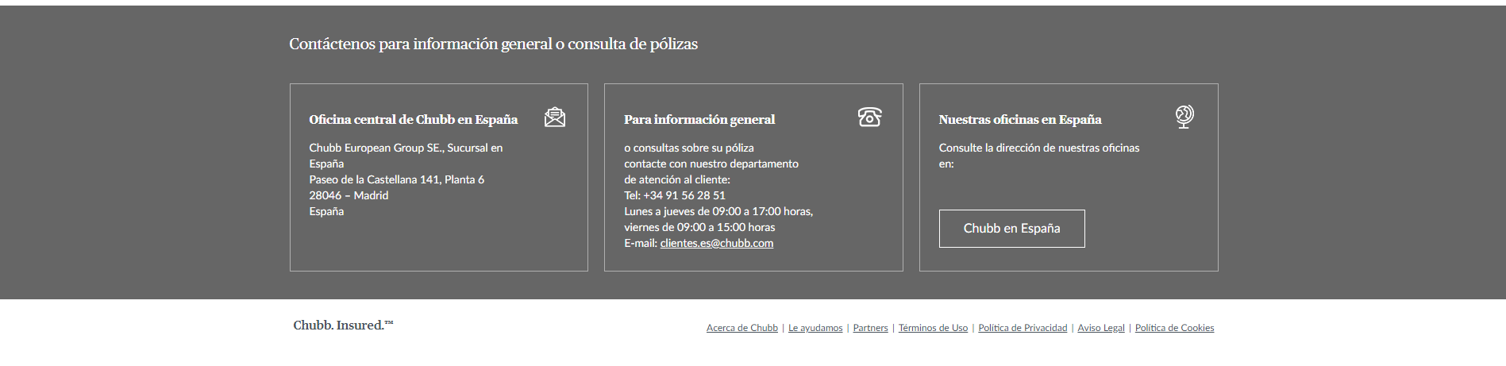

**CTITH (Old Design)**

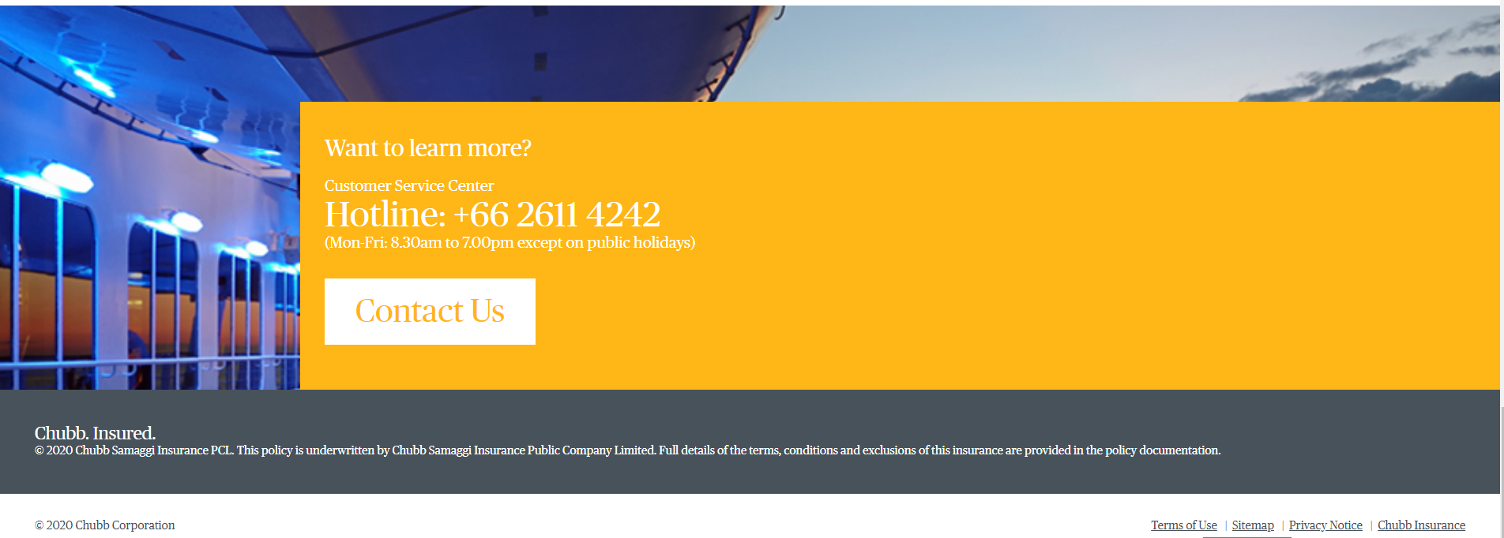

**Site Map Component**

